**Estonia Vies for EV Leadership in Europe**

By [**Laurent J. Masson**](http://www.plugincars.com/user/laurent-j-masson) · February 22, 2013

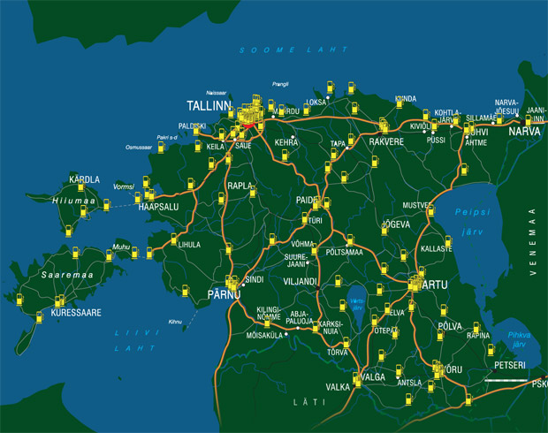

On Estonia highways, drivers are never more than 37 miles from a high speed charger, while in the cities, chargers are very conveniently located, next to shopping centers, post offices or bank buildings.

Every European country is working in some capacity to develop electric mobility. It's a bit of a race, and like in every race, there are leaders. The clear leader is Norway, by a wide margin. Norwegians have already ordered more than 1,100 units of the [Tesla Model S](http://www.plugincars.com/tesla-model-s), but right behind is another country from Northern Europe: the little Baltic state of Estonia.

Not many people saw Estonia coming. The first big news about EVs in Estonia was from Mitsubishi in October 2011. [The government ordered 507](http://www.motornature.com/2011/10/when-it-comes-to-electric-cars-the-estonian-government-is-leading-the-world/) [i-MiEV](http://www.plugincars.com/mitsubishi-i-miev) cars. That's the largest single order Mitsubishi has ever received for its little car, but though impressive, that wasn't enough to prove the country's commitment.

All countries have a large fleet of vehicles for civil servants, and a single person's decision can put hundreds of drivers behind the wheel of an electric car. More was expected, and that came by chance when I happened to meet some Estonians last year in Monte Carlo. They were driving a 1958 Gaz M20. That car, known as the *Pobeda*, was converted to electric propulsion.

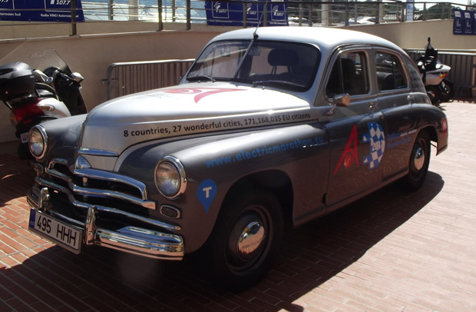

1958 Gaz M20 Pobeda, converted to electric by Estonians.

It was hard not to be impressed. Taking a Russian car more than 50 years old (technology from the 1930s inside), converting it to an electric drive, and driving it nearly 1,800 miles to Monte Carlo? Those Estonians are serious about electric cars. So serious that they organized a rally, with the second edition taking place this May. It goes from [Tallinn (the capital of Estonia) to Monte Carlo](http://electricmarathon.eu/). It's open to all EVs and longest stage is a reasonable 112 miles, so a [Nissan LEAF](http://www.plugincars.com/nissan-leaf) (with some careful driving) can compete. But only hardcore EV fans will participate. So will average Estonians be supportive of electric mobility?

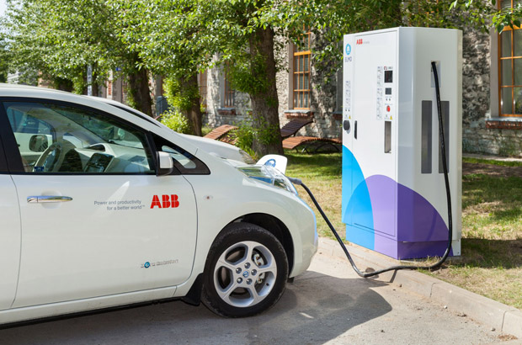

ABB fast charger in Estonia.

I think so. Their government has launched the best network of fast charge stations in Europe. This is where it helps that Estonia is a small country. It's a bit smaller than Lake Michigan, meaning that only 165 fast chargers were needed to give the country a respectable network. On highways, drivers are never more than 37 miles from a high speed charger, while in the cities, chargers are very conveniently located, next to shopping centers, post offices or bank buildings.

The government's idea was that EV charging should be fuss-free, fast and uncomplicated. The government succeeded. It's also accessible to most EVs thanks to ABB, the manufacturers of all chargers, which installed dual units. Each charger has a 50-kW Chademo port (for Japanese EVs like the Nissan LEAF) and a 22-kW AC plug (for Renault or Smart EVs). Many people talk about those new dual chargers, but they are already deployed nationwide in Estonia.

Payment is uniform across the whole network, with three schemes to choose, depending on the expecting number or charging sessions per month. The volume package is €30 ($40) for up to 150 kWh. That's not exactly cheap, but Estonia has no plan to give energy away. The charging stations network has to be economically sustainable. The service opened this week, and as of today, there are less than 500 EVs in private hands in Estonia. With only 1.3 million people, there will never be millions of EVs in this country, but it's a reasonable hope that EVs will very soon take a substantial share of the new car market. Again, government's intervention will help a lot since incentives can take 40 percent off the price of a Nissan Leaf in Estonia. Maybe EV fans from Southern Europe should consider moving to the Baltic country.